Argulus egg removal project. 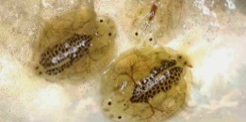
2020 was the third year of a project to reduce the population of the parasite argulus that affect our trout. The erratic jumping from and splashing on the surface of the water is a sign that a trout is infected with the parasite and is attempting to shake them from their skin. In 2018 forty posts were placed in the lake over which a one meter length of black plastic pipe 110mm in diameter was placed. It was hoped that the female argulus would lay eggs on the pipes and by inspecting the pipes every 14 days the eggs could be removed. The guidance for this project came from the Environment Agency and their fact sheets are at the end of this report.
Alan Davis, Dennis Willis and Graham Gamble, with some assistance from EA staff, started the project on the 17th April 2018. By the end of November an estimated total in excess of 850,000 eggs were removed. It was hoped this would have impacted on the argulus population and was possibly reflected in what appeared to be fewer trout jumping erratically during 2019.
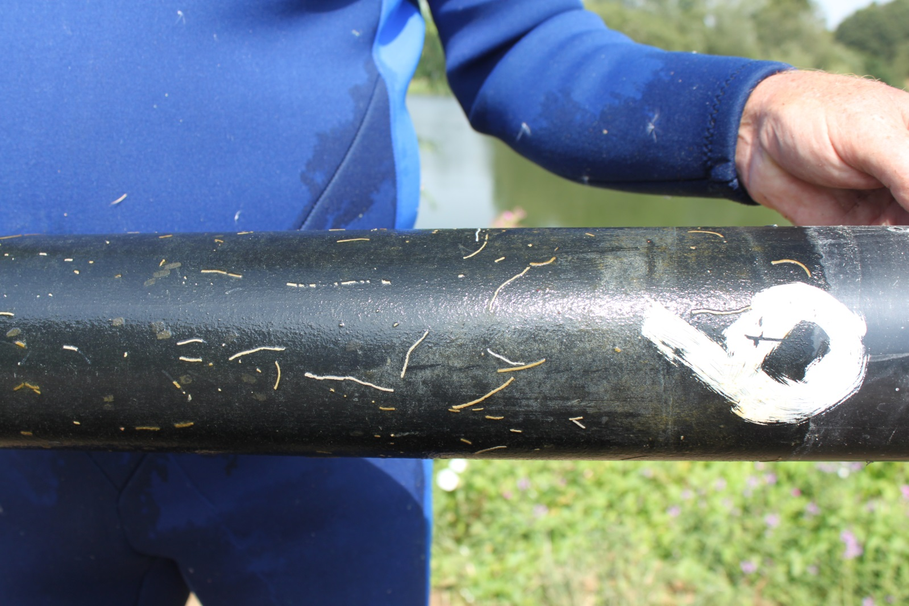
7th August 2018
Pipe number 9 shows some of the strings of argulus eggs that had been laid on the pipe.

In a similar period in 2019 an estimated total of 413,000 eggs were removed. The removal of the pipes during these two years was carried out by entering the water and replacing the pipe with a clean one. Alan (AKA the blue whale) carried out most of the removal whilst Dennis took photos, did the counting and recording and Graham cleaned the pipes ready for next time.

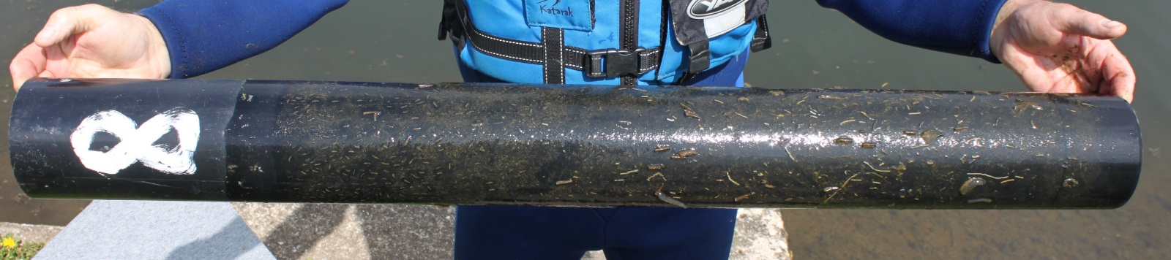
Pipe 8 30th April 2019

Lockdown because of COVID19 delayed the start of the project in 2020. Aside from normal health and safety procedures whilst doing the work in and beside water COVID19 guidance meant personnel had to work at a safe distance. It was also decided to use fewer pipes to cut down the workload. Pipes were placed over posts where in the previous two years egg laying had been most prolific. Alan did go in the lake for the first two weeks of removals. However Dennis experimented by fitting loops to the pipes. The use of a suitable pole (an old take apart composite fishing pole) with hook enabled the pipes to be removed and replaced without going in the water. This allowed for one person to safely continue the project and proved successful. Between July and December over 313,000 eggs were removed and these from only sixteen pipes.
Egg-laying usually starts when the water temperature reaches 10°C and continues through the year until water temperature is below that figure. There can be two peak periods of egg-laying and it would appear the occurrence of these is affected by water temperature, clarity and amount of weed/reed growth. So whilst we cannot be sure when these occur it is thought we missed the early peak period around May/June in 2020.
Loop for recovery and of pipe
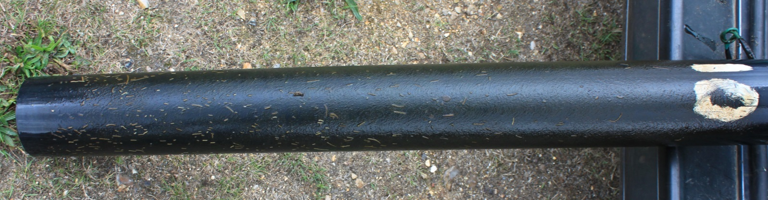
Pipe 10 26th August 2020
The pipes have also proved to be suitable for other invertebrates in the lake to visit and to lay their eggs upon.
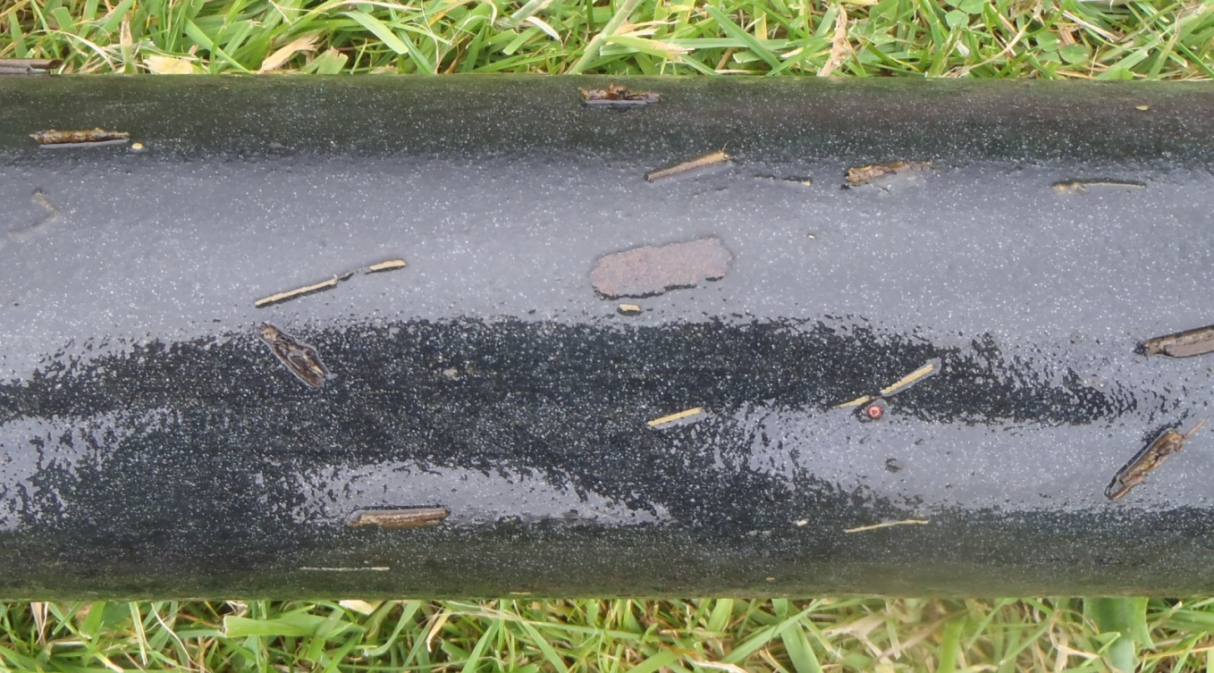
Brown mite eggs
Caddis
Red mite
Argulus eggs
Caddis

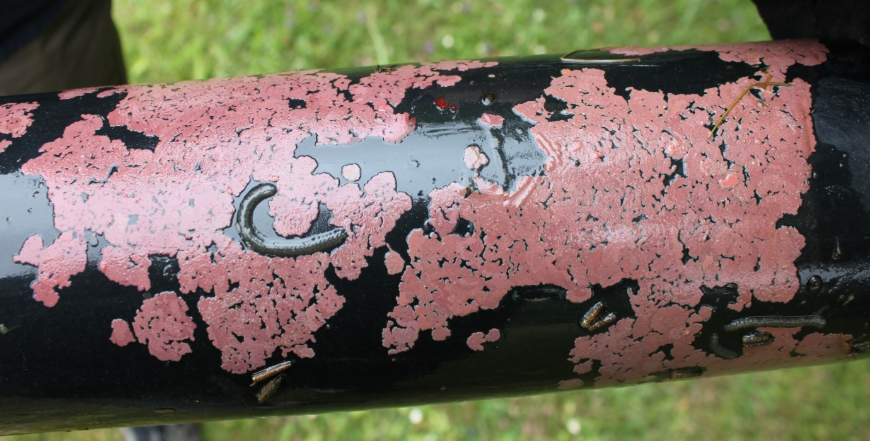
Red mite eggs
Red mite eggs
snail eggs
caddis
caddis
Red mites
snail eggs
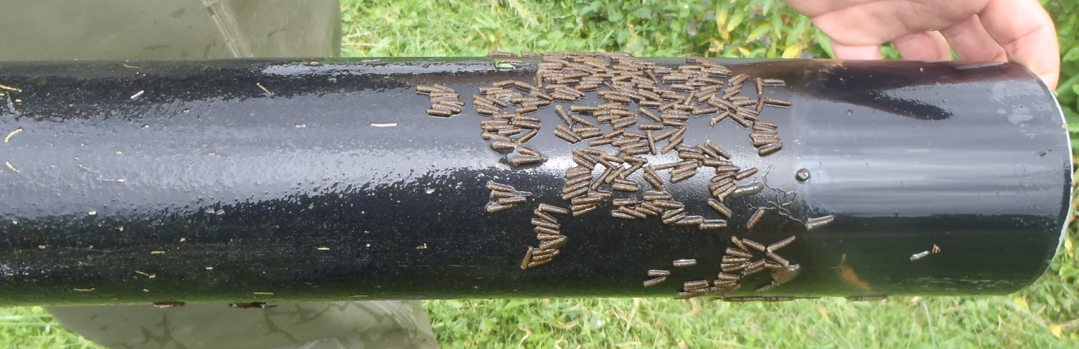
caddis
Snail eggs
snail
Argulus eggs
caddis
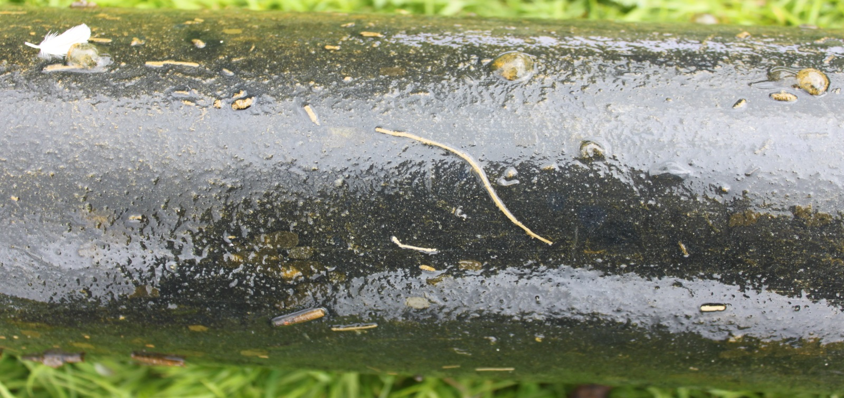
This string is mostly three eggs wide and there are probably over 600 eggs in it
Snail eggs
Green eggs still unidentified
caddis
There are 69 argulus eggs in this string which is mostly two eggs wide
The number of argulus eggs strings and hence eggs removed are from an approximate count.
The pipe positions, argulus egg numbers, dates, water temperature and water clarity have been recorded and maintained in a spreadsheet. Photographs of the pipes were taken for the record.
Anybody wishing to have more details is invited to contact Dennis (den207willis@dsl.pipex.com).

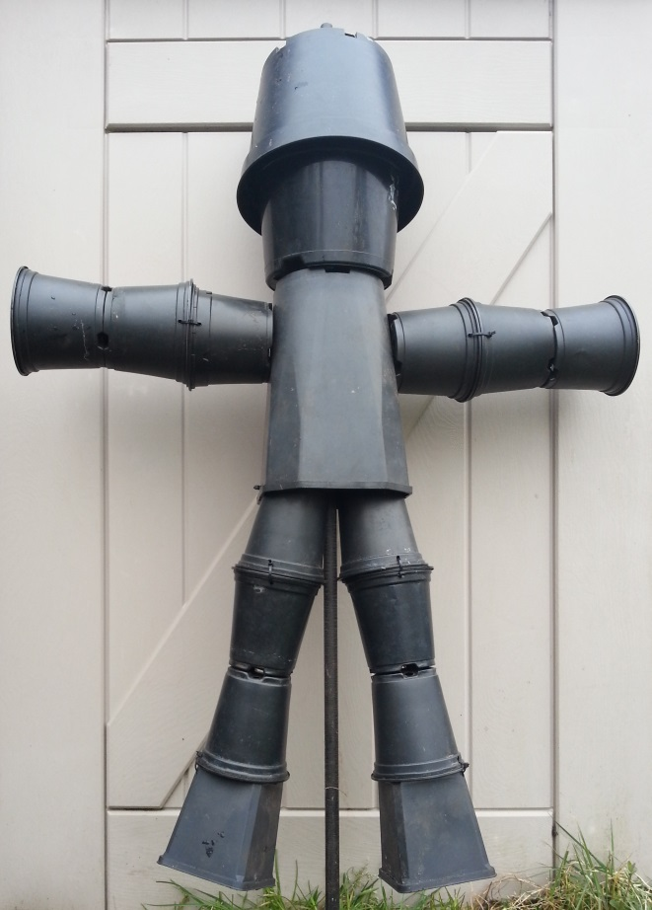 © Dennis Willis January 2021
Mr ARGULUS joined the team at the start of the project. He was created in an attempt at recycling some black plastic flower pots.
He was successful in attracting the female argulus as well as many other invertebrates in the lake.
However giving him a scrub up afterwards was quite labour intensive. So from then and for now he will remain out project mascot.
Below are Environment Agency guide sheets.

